**Quantitative data**

**There are three cultural sources: local, target, and international. Have you been familiar with cultural sources before?**

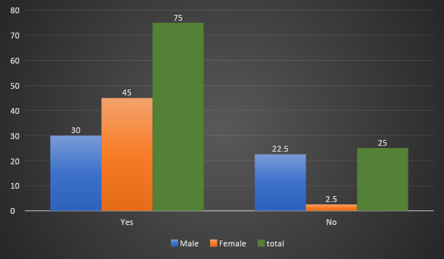

This bar shows the responses of Yes/No question whether the participants were familiar with three cultural sources (Local, target, and international). The majority of the participants (total 75%) know the terms local, international, and target source before. Among them 45% is female and 30% male. In contrast, among 25% negative responses, 22.5% is male and only 2.5% is female.

**To what extent do you understand cultural aspects when you read the English textbook?**

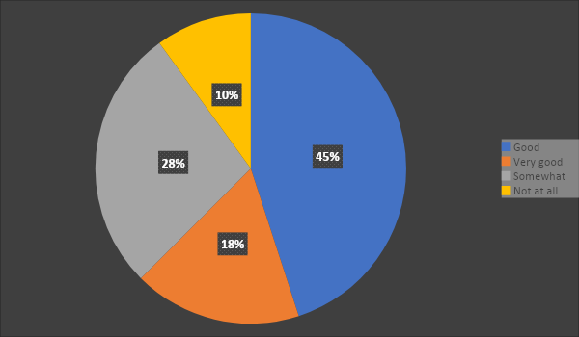

This pie chart represents the degree of how the student understand of cultural aspects while they read the English textbook. The measurement shows in the percentage. The greater portion the responses (45%) understand the cultural aspects in their textbooks. however, the numbers of responds who understand somewhat of cultural aspects of the textbook is 28%. Although, 18% students get the things very well but 10% of them don’t understand it at all.

**How do you feel the cultural content is presented in the textbook?**

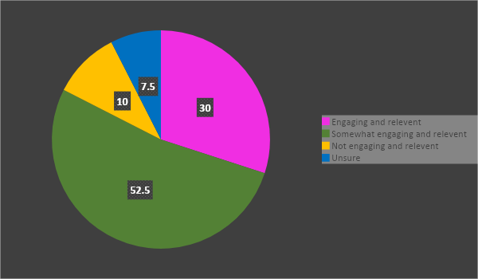

This pie chart depicts the data of the students showing the feeling in the cultural contents which are presented in textbook. Though more than half participants (52.5%) feel that cultural contents are engaging and relevant, 7.5% of the students are unsure about it. The participants (10%) who feel it somewhat engaging and relevant are a bit more than them who (7.5%) feel that the content is not engaging and relevant.

AAAA

**To what extent do you see a connection between the cultural content in the textbook and your own cultural background and experiences?**

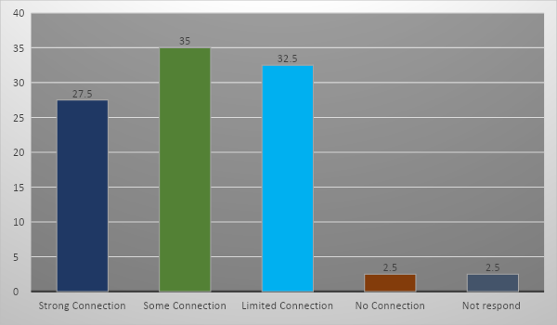

This bar graph descries the participation the students to show the degree of the connection students’ own culture and experience with cultural contents of the textbook. Units are showing in percentage. The connection between textbooks’ culture and participants’ own experience is somehow relevant (35%). Though participants (27.5%) seem they have strong connection, 32.5% finds it limited connected. Moreover, 2.5% which represents number of one sample of total 40 samples think there is no connection between them and one does not respond.

**What do you think which sources should be included more in the textbook?**

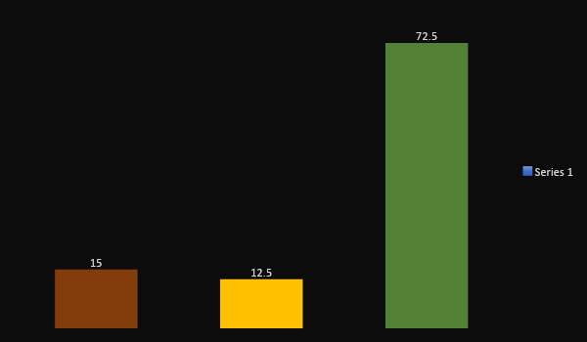

**Do teachers explain the cultural content while teaching?**

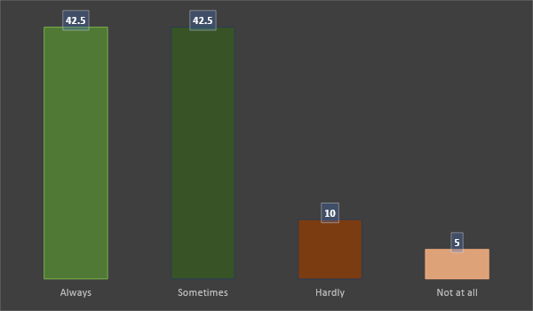

**Which cultural source will help learning English more?**

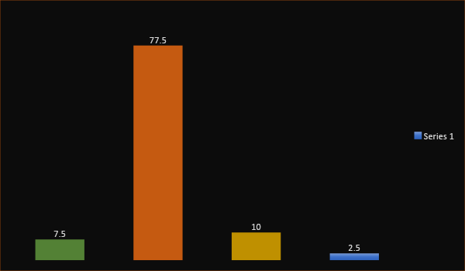

**Do you think cultural content makes the text interesting for learning?**

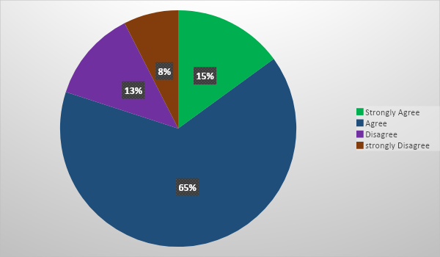

**How do you think cultural content helps to improve your English communication skills?**

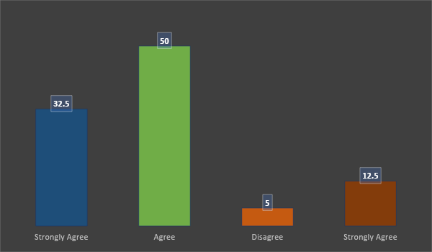

**How do you think learning about cultural content improves your understanding of the English language?**

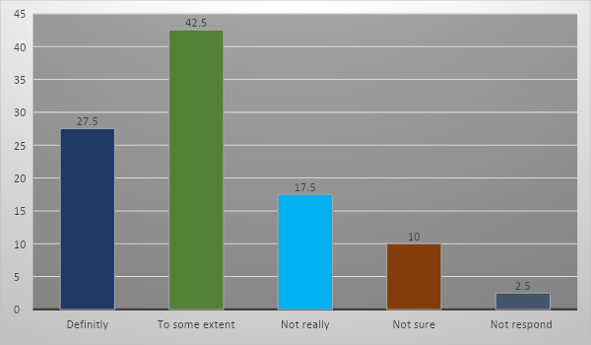

**How do you think cultural awareness helps to speak fluently?**

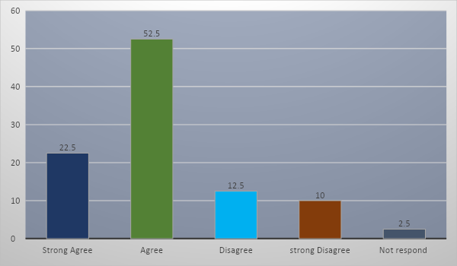

This bar chart illustrates responds of student of how much they agree or disagrees on the question of if the cultural awareness helps to speak fluently. The units show the percentage rate or ratio. The most of students agreed (52.5%) that cultural awareness helps to speak fluently. The second large participants strongly agreed (22.5%). On the other hand, the negative ratio of the participation is 12.5% of disagree. Although 10% of the students strong disagreed, 2.5% of the participants do not respond.